**Experiment - 1.4(a)**

**Student Name: Milan Sharma UID: 23MAI10003**

**Branch: ME – CSE - AIML Section/Group: MAI – 1 (A)**

**Semester: 1st Date of Performance: 29 Aug 2023**

**Subject Name: Python Programming Subject Code: 23 CSH 623**

1. **Aim of the Experiment :**

Write a python program to illustrate the concept of range() Function

1. **Objective of the Experiment :**

To illustrate the concept of range() Function

1. **Algorithm/ Steps for Experiment**

In simple terms, range() allows the user to generate a series of numbers within a given range.

Depending on how many arguments the user is passing to the function, the user can decide where that series of numbers will begin and end as well as how big the difference will be between one number and the next. range() takes mainly three arguments.

1.        start: Optional. An integer number specifying at which position to start. Default is 0

2.        stop: Required. An integer number specifying at which position to stop (not included).

3.        The range of integers ends at stop – 1.

4.        step: Optional. An integer number specifying the incrementation. Default is 1

1. **Code for Experiment :**

x = range(3, 20, 2)

for n in x:

print (n)

1. **Result/Output :**

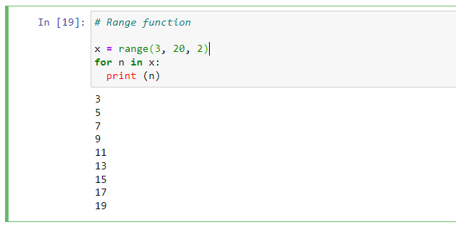

**Learning outcomes (What I have learnt):**

1. Learnt the use of range function.